Instructions for CCMCC app for students
You should have already received an invitation to the placement Pro app at the time of enrollment.
Start by downloading the CCMCC app from the app store
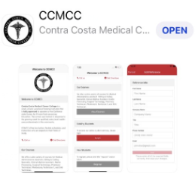
FIRST: Register as a new student, but clicking register (grey button)
If you get a notice that says you haven’t been invited -Email: Sue@ccmcc.edu
Note: you must allow location and camera access for this app
Second: Login with the red login button

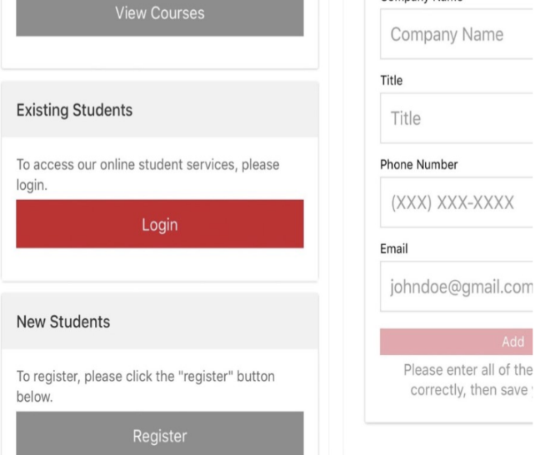

Choose your program, (see example below image)
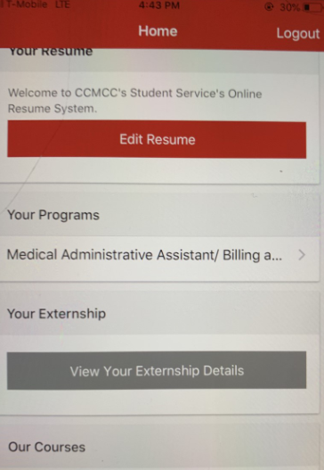
Select the red Add + button to bring up the scanner via your camera, hold the phone so the scanner can scan the bar code. If it was a success you see the date added to your attendance
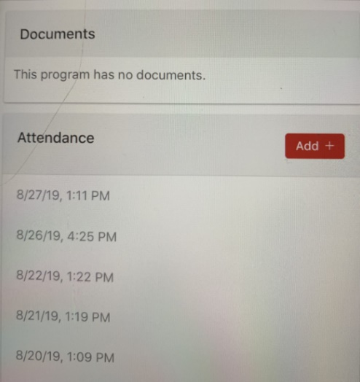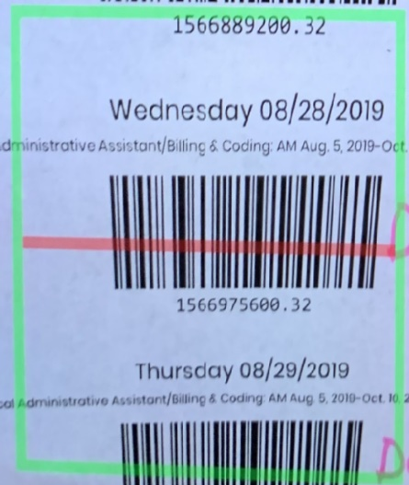

If you have an error code that your location cannot be found, go into your map app and have it find your location, then retry.
If it states wrong cohort, or you are not enrolled in a course
Email: Sue@ccmcc.edu
If the error says barcode is for another day, double check you’re scanning the correct day and class.
If it is an Error2 - scan already in process, log out and try again.

