Instructors
The website for Placement Pro for your scanned attendance is: https://ccmcc.placement-pro.com
Chris will give you your log-in information
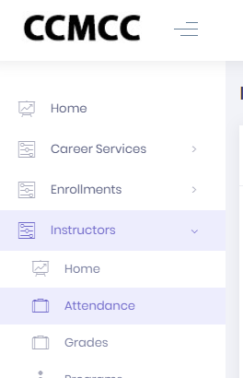
Once you are in the website follow these directions to print your bar code(s) for students to scan.
Click Instructor in the left-hand panel
Click Attendance from that drop-down menu
A list of courses will pop up with a purple box next to it that reads view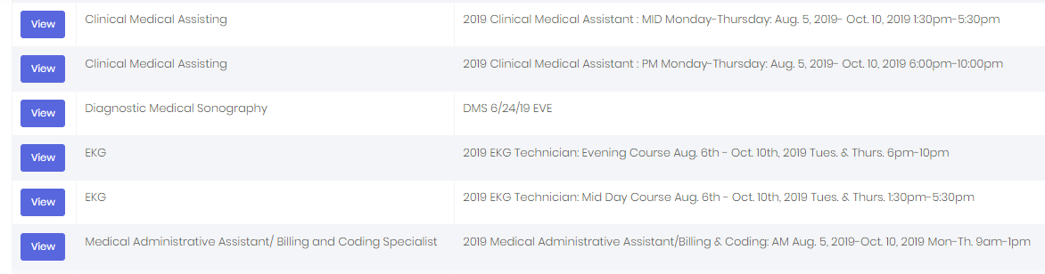

Choose your course, note the different times for 9-1 or 6-10pm

MA programs, click on your main course, example: Clinical Medical Assisting and all of your students will be organized within that course title. “Todays” attendance will auto populate.

In the upper right-hand corner, you will see print
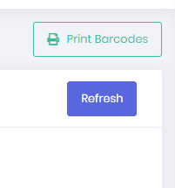
barcodes in a green box

Once you click on that icon it gives you the option to toggle the days of week your class is scheduled. Example Monday- Thursday, toggle off Friday and Saturday
Then you have the option choose the number of weeks.

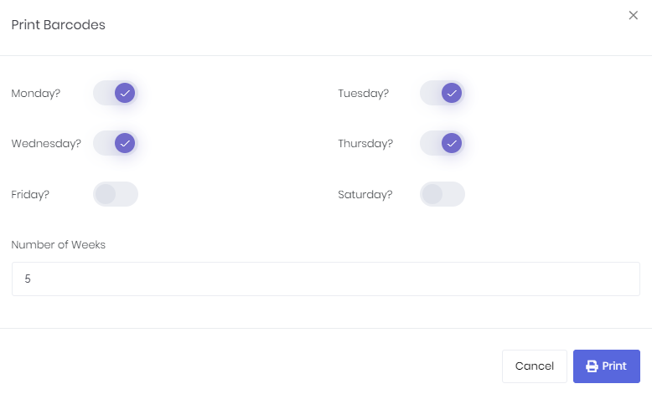
If your course is 10 weeks long, you have the option of printing all the bar codes for the entire length of the program. Click the purple print button.
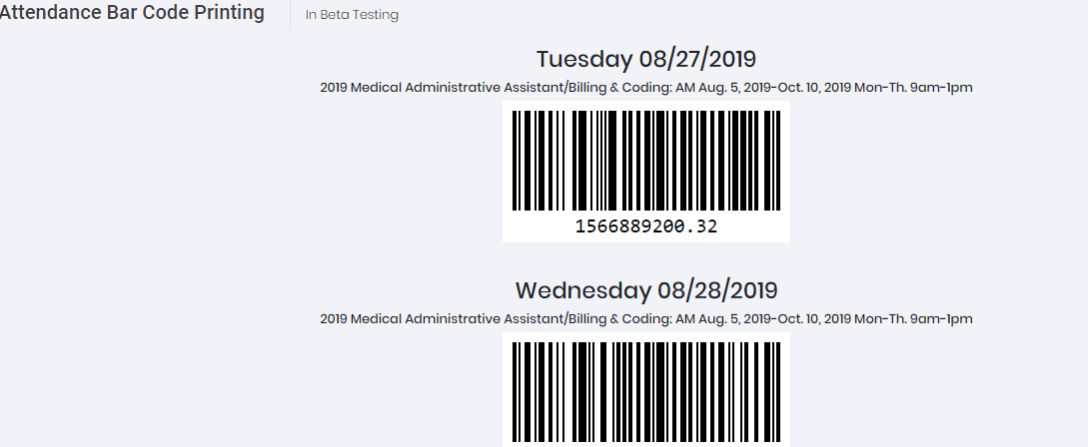

Click Ctrl- P to print the bar codes. You can cut them into strips and put it someplace where all your students will have access to scan it with their phone, using the CCMCC app.
To confirm all students have successfully scanned in, go back to attendance (left hand panel) select your program, you will see green check marks or red circles. If all students are checked in, a green check mark will appear, if they have not scanned in a red circle will remain next to their name. You still go to diamond and save them as present (as we’ve always done) If there’s an issue with a student scanning in, for example they forgot their phone, you can Ctrl- P to print the screen below with an explanation of the error, and leave for the registrar in their door box. 